REPORT
Question 1: C# Contact Management Application
The first assignment involved the use of a C# console application to store a list of contact details. There were two important classes used to organize the program: a class to represent each contact and a class to manage the list of contacts. The solution utilised properties, constructors and list of objects in order to structure and store information efficiently. The user can use the system by using a menu containing actions, as they can create new contacts, update existing information, delete them, or view the entire list. The system was designed with input validation particularly to the mobile number field which had to follow a set format in nine digits. The assignment solidified the fundamental principles of object-oriented programming and reflected on how one can design small systems on the principles of classes and modular functions.
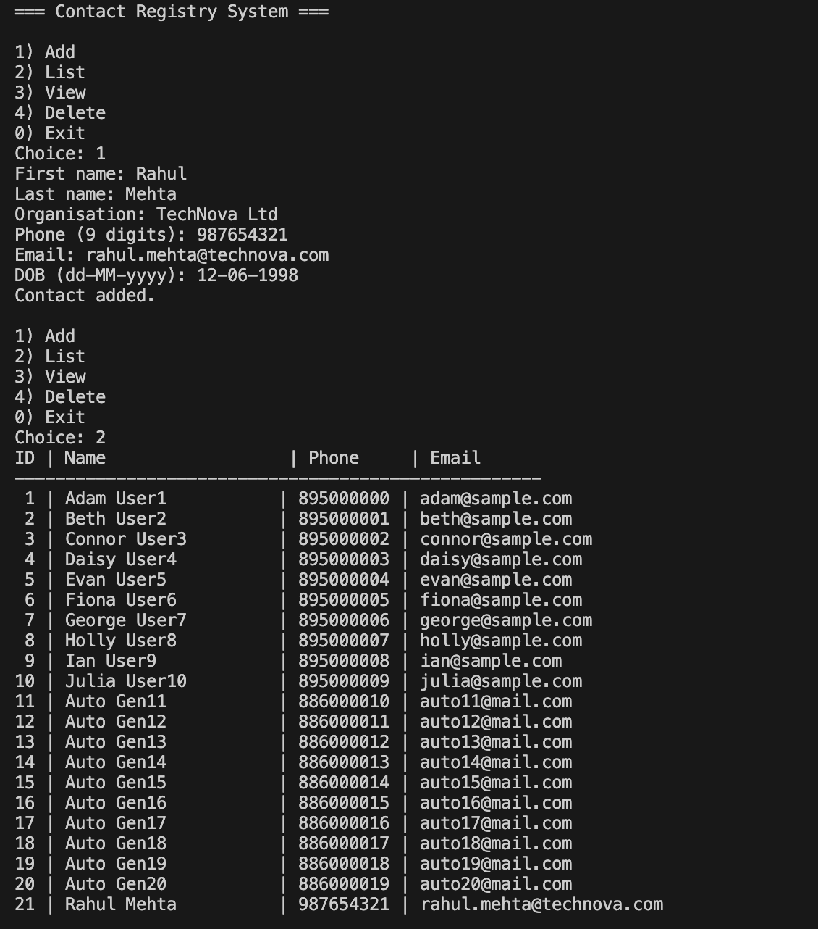
Question 2: File Extension Lookup Tool in C#
The second question demanded creation of a database of file extensions. The user also inserts an extension in the application and a short description of that kind of file is retrieved. The core structure was a dictionary as it offers quick access through key-values and is able to store the needed extension-description pairs in a clean environment. The dictionary counted over twenty typical formats representing various types of documents, media files, compressed archives and program scripts. The tool was created in such a way that it answers invalid or unknown input in a clear manner, so that the user always gets useful feedback. This exercise enhanced the knowledge of associative data structure, user input processing, and basic user tutorial navigation.
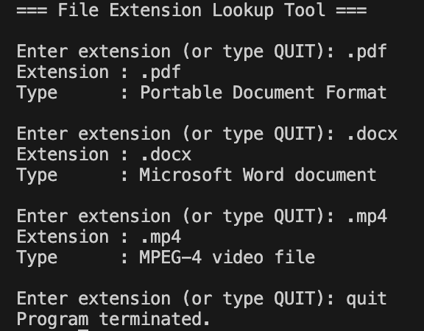
Question 3: Client-Server Application System in Python
The third activity was on implementing a simple TCP client-server application in Python. Client would collect student application data such as personal data, qualification, course of choice and desired start date. Having entered the information, it is coded in the JSON format and dispatched to the server. The server checks the received data and creates a unique registration code and stored the entire application in an SQLite database. It subsequently sends the new registration code back to the client as a confirmation. The server was set up to support a number of client requests, and used each connection in a separate thread. This assignment proved to be a practical experience in socket programming, database access, and designing communication protocols with the layer of consistency and data integrity.
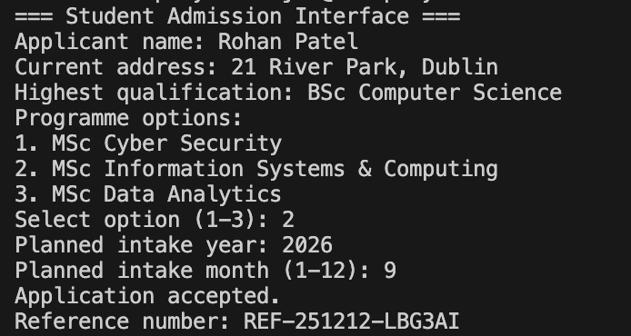
Question 4: Extraction of Hotel Pricing Data in Python
A hotel room pricing comparison system was built in the fourth task. As part of the legal data-use requirements, two separate HTML files were created to describe two different hotels, each with a variety of room types and price information. The program has used BeautifulSoup to read, extract and fuse the relevant room and price fields of both files into one dataset. This was then stored in a CSV file which could be accessed in structured form and finally shown in the terminal which could be reviewed by the user. The solution was the demonstration of HTML parsing, CSV file manipulations, and simple data consolidation methods. It also demonstrated the way one can safely apply scraping logic without relying on third-party websites.
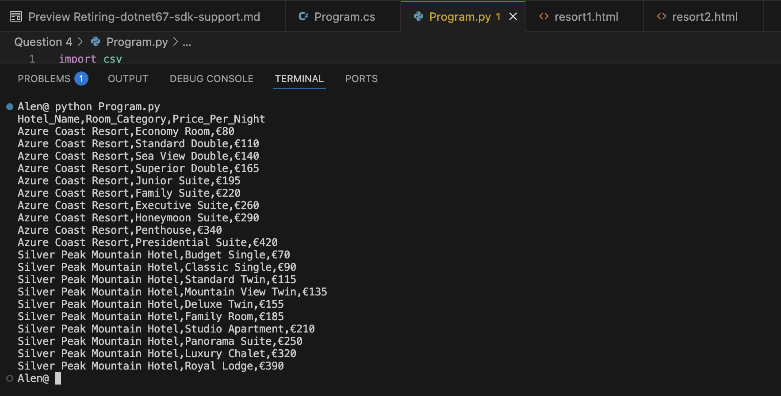

Appendix
Github Link: https://github.com/alensaju93-dot/Advanced-Programming-CA-1

